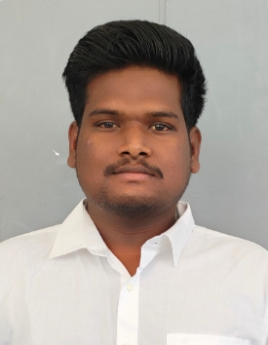
VEERADEEPAK.A
M.E(Embedded System and Technology )
Contact No. : - 9003659008 & 9360832066
E-mail:- veeradeepak5898@gmail.com
Present Address:
1276, K.A.V, illam government higher secondary school ,
Main road , ulagampatti , ulagampatti (post) , tirupathur (thaluk) , sivagangai (district).
Pin code:630410

CAREER OBJECTIVE

Looking for a promising and challenging career which will enable me to provide best of my skills. A career which can sharpen my current skills and knowledge and where I can have a good scope for learning and implementation new technologies.

BASIC ACADEMIC CREDENTIALS

Qualification | Board/University | Year | Percentage
M.E(Embedded System and Technology) | Velalar College of Engineering  And Technology | 2021 - 2023 | 9.54  (CGPA)
B.E(Electronics and Communication Engineering) | Vidyaa Vikas College of Engineering  and Technology | 2016 - 2020 | 6.3  (CGPA)
Higher secondary school | Vidyaa Vikas Boys Higher Secondary  School / State board | 2015 - 2016 | 62.58%
SSLC | Chidhambaram Matriculation Higher  Secondary School / State board | 2013 - 2014 | 84.40%

IT PROFICIENCY

- Embedded C (arduino,PIC and ARM(basic))
- Language C

FINAL YEAR PROJECT

- B.E project Arduino microcontroller use “TIME MANAGEMENT IN TRAFFIC SIGNAL BASED ON VECHICLE DENSITY AND EMERGENCY VECHICLE” based on Embedded System

CO-/EXTRA –CURRICULAR ACTIVITIE

- Actively participated in WORKSHOP title is “EMBEDDED C”
- Actively participated in WORKSHOP title is “RECENT TRENDS IN ELECTRONICS ENGINEERING”
- Actively participated in WORKSHOP title is “ETHICAL HACKING”
- Actively participated in WORKSHOP title is “IOT”
- Actively participated in paper presentation title is “THE PRESENT,PAST AND FUTURE ROBOTICS”

ACHIEVEMENT

- Journal published for “TIME MANAGEMENT IN TRAFFIC SIGNAL BASED ON VECHICLE DENSITY AND EMERGENCY VECHICLE” based on Embedded System

FIELD OF INTEREST

- Embedded C program
- Hardware testing and design

INTERPERSONAL SKILL

- Listening skills
- Problem solving
- Decision making
- Assertiveness

PERSONAL DETAILS

- Father’s Name :- Arumugam. K
- Date of Birth :- 05thAugust 1998
- Language Known :- Tamil & English
- Marital Status :- Single
- Nationality/Religion :- Indian / Hindu
- Interest & Hobbies :- new technology learning

DECLARATION

Hereby to declare that the above information is true to the best of my knowledge.

Place: Erode A.Veeradeepak
Date: (Signature)
